**Parent,**

When the superintendent sends out a message that Fort Payne City Schools (**NOT DeKalb County Schools**) will be delayed, this is the schedule that we will follow at Little Ridge Intermediate School. **ANYTIME SCHOOL IS DELAYED, A GRAB AND GO BREAKFAST WILL BE SERVED.**

**School Delay Schedule**

**1 Hour Delay**

Teachers on Duty 8:05 AM

Doors Open 8:10 AM

Teachers 8:30 AM

School Starts 8:45 AM ***Students must be in the building at this time or they are considered late***

*Buses will run 1 hours later than normal

**2 Hour Delay**

Teachers on Duty 9:05 AM

Door Open 9:10 AM

Teachers 9:30 AM

School Starts 9:45 AM ***Students must be in the building at this time or they are considered late***

*Buses will run 2 hours later than normal

**2 ½ Hour Delay**

Teachers on Duty 9:35 AM

Doors Open 9:40 AM

Teachers 10:00 AM

School Starts 10:15 AM ***Students must be in the building at this time or they are considered late***

*Buses will run 2 ½ hours later than normal

**3 Hour Delay**

Teachers on Duty 10:05 AM

Doors Open 10:10 AM

Teachers 10:30 AM

School Starts 10:45 AM ***Students must be in the building at this time or they are considered late***

*Buses will run 3 hours later than normal

Thank you for your patience and understanding during these weather events.

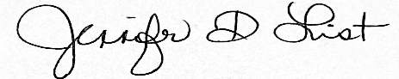

Jennifer List

Principal